Gradient boosting regression:
Gradient boosting regression is a supervised machine learning technique that creates a strong predictive model by sequentially combining multiple "weak" decision trees. In each step, a new tree is trained to predict the errors of the previous model, and its prediction is added to the ensemble to improve accuracy.
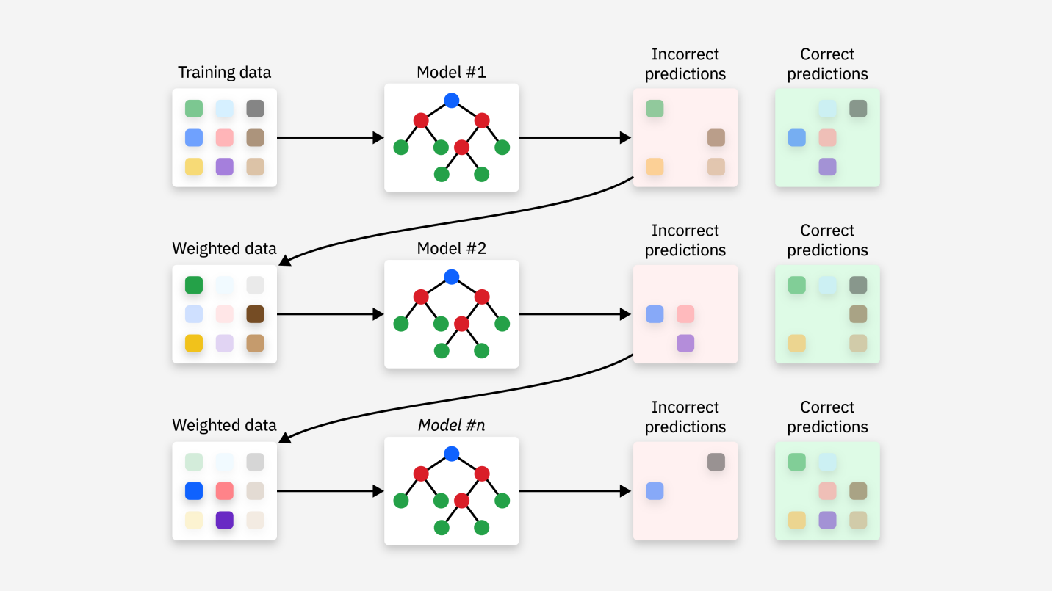

Adaboost algorithm:
The AdaBoost (Adaptive Boosting) algorithm is an ensemble learning method that combines multiple "weak learners" to create a strong, accurate predictive model, primarily used for classification tasks. It operates iteratively, focusing on improving the performance of these weak learners, which often perform only slightly better than random guessing.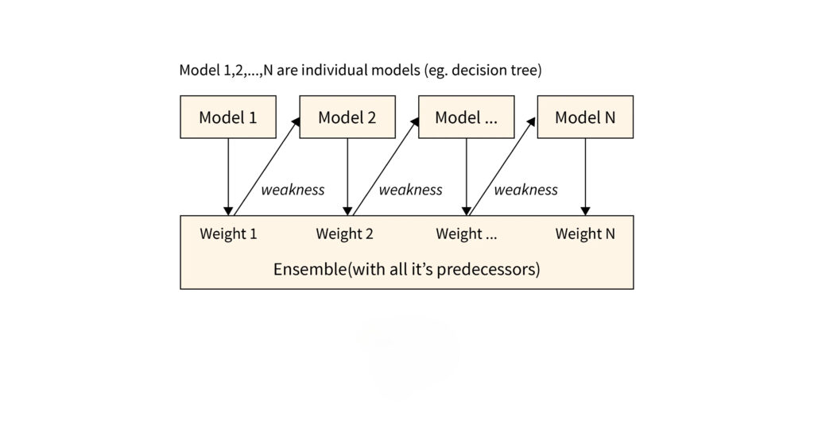
XG boosting algorithm:
XGBoost, which stands for eXtreme Gradient Boosting, is a powerful and popular open-source machine learning library known for its efficiency, flexibility, and high predictive performance. It is an optimized and scalable implementation of gradient boosting, an ensemble learning method that combines multiple "weak learners" (typically decision trees) to create a more robust and accurate "strong learner."

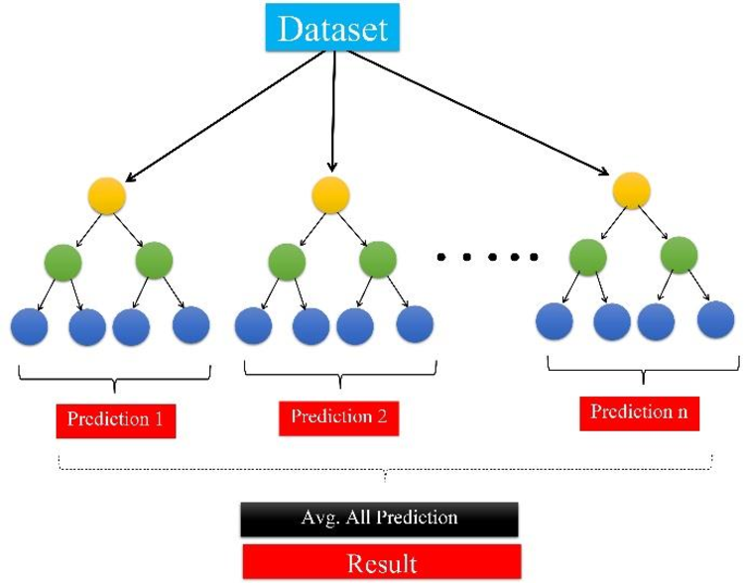

LG boosting algorithm:
The LG boosting algorithm is more accurately referred to as LightGBM, which stands for Light Gradient Boosting Machine. It is an open-source, high-performance gradient boosting framework developed by Microsoft, designed for efficiency, scalability, and accuracy, especially with large datasets.

